To show M and F as Male and Female

To do this we are creating a data type with Name and Gender as data type

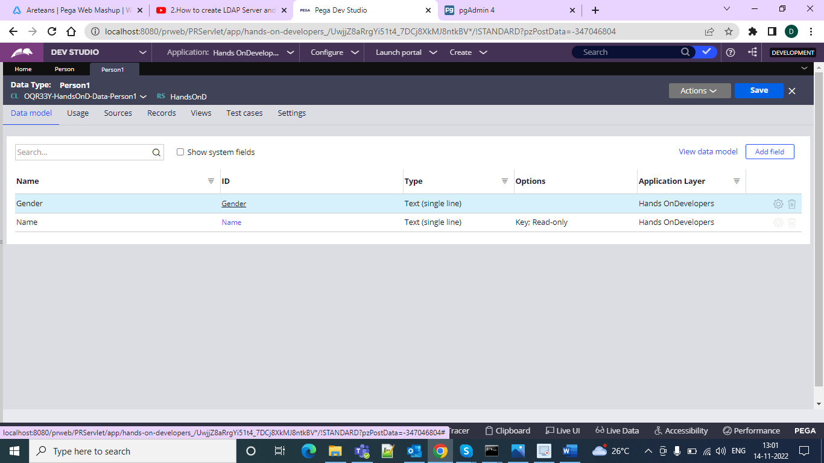

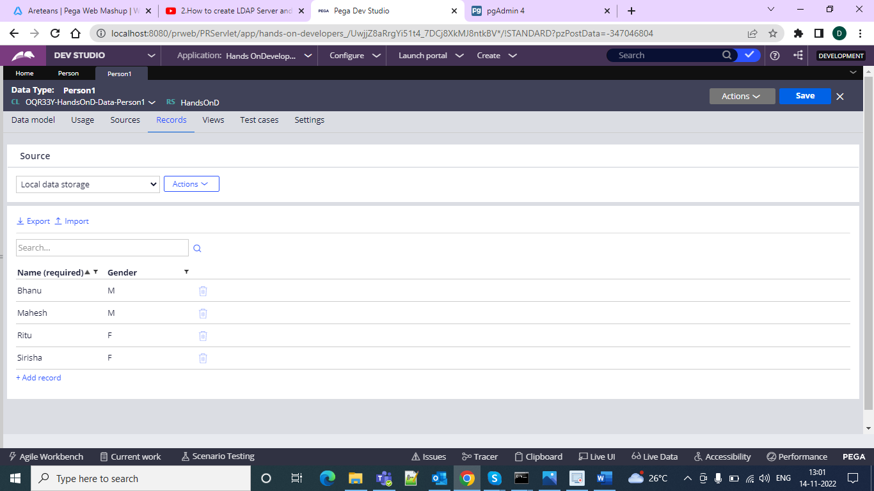

And after that refer this inside a section create a case and flow

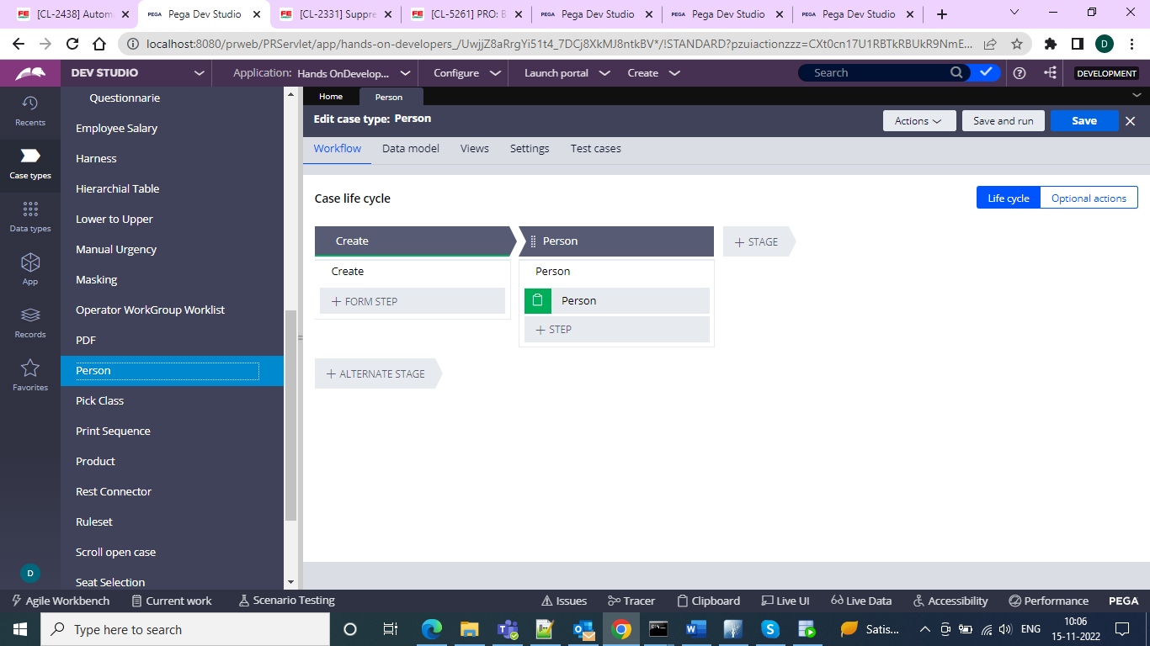

And after this we need to call our data type properties and the section as table format

And in that we can have the columns for table and visibility conditions

And for the female we can have the label and visibility conditions on this one and we can show in the section

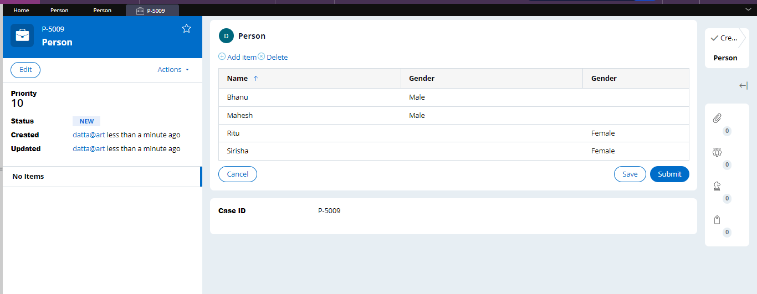

And it will look like this but in the data type will be shown as ‘M’ and ‘F’

And now go for the report and use the functions of the replace

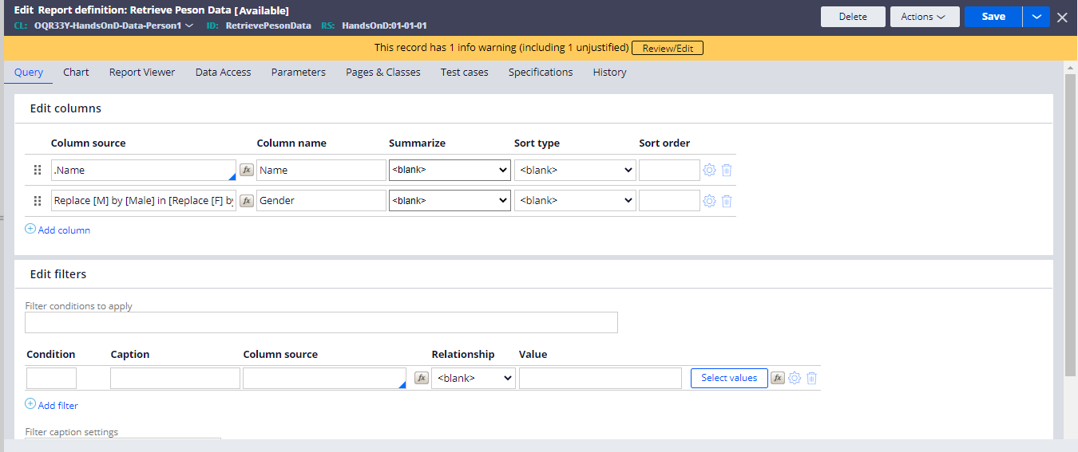

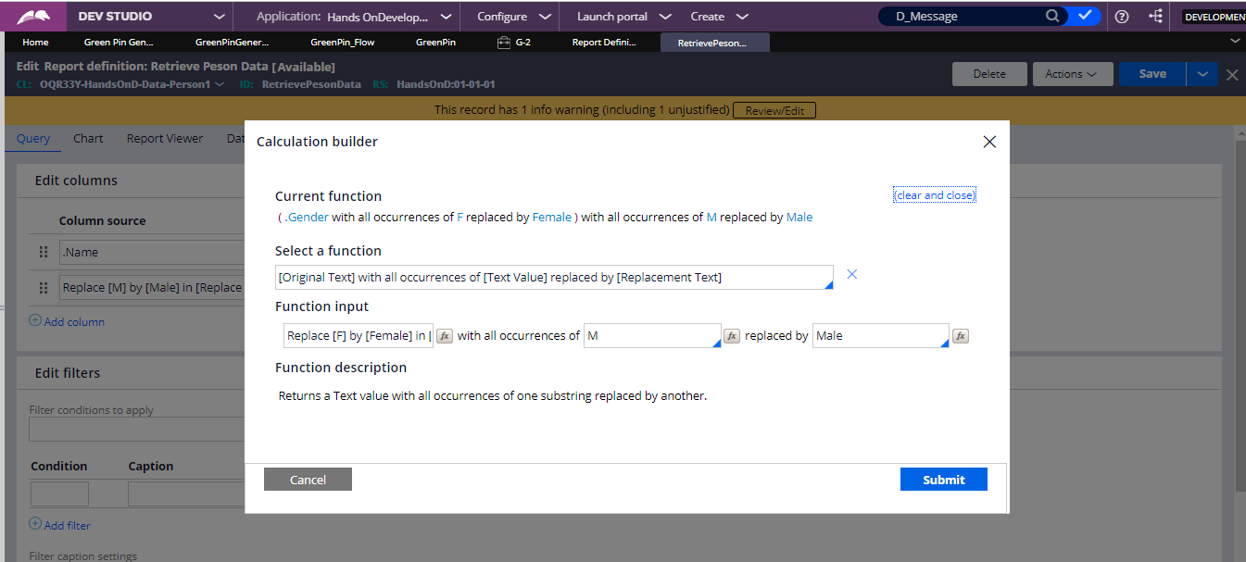

And if you run the report

You will see the male and female

